**Lab Program: 03**

**For a given set of relation schemes, create tables and perform the following simple queries, simple queries with aggregate functions, Queries with aggregate functions (group by and having clause).**

**Step 1: Create table salary.**

**SQL> Create table salarydB**

**(ENO varchar(8) primary key,**

**NAME varchar(15) Not Null,**

**DEPT varhcar(10),**

**DOJ Date,**

**Salary float(10,2)**

**);**

**Table created**

**Execution:-**

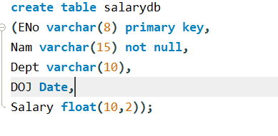

**SQL> Desc salarydb;**

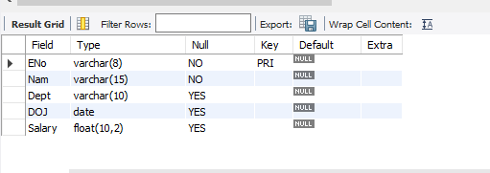

**Step 2: Enter five tuples into the table.**

**SQL> INSERT INTO salarydb values (‘Sc1011’,’Ahana’,’HR’,’2010-02-15’, 60000);**

**Execution: -**

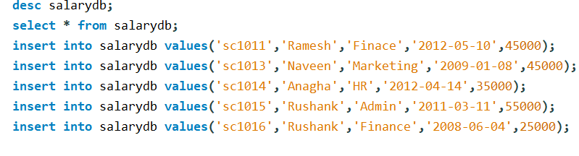

**Select * from salarydb;**

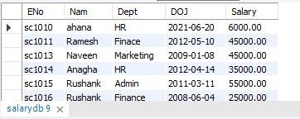

**Step 3: Display Employee number (EN0) and salary**

**SQL>** **select Eno,salary from salarydb;**

**Execution: -**

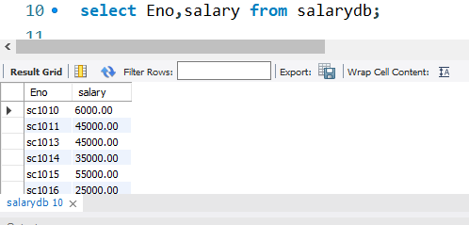

**Step 4: Find the sum of salaries of all the employees.**

**SQL>** **select sum (salary) as “TOTAL_SALARY” from salarydb;**

**Execution: -**

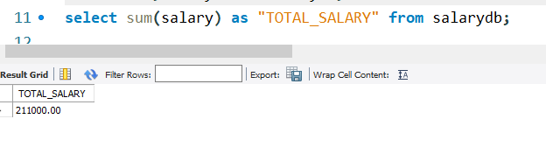

**Step 5: Find the sum and average salaries of employees of a particular department.**

**SQL>** **select dept, sum(salary) as "TOTAL_SALARY",**

**AVG(salary) as "AVERAGE_SALARY"**

**from salarydb group by dept;**

**Execution: -**

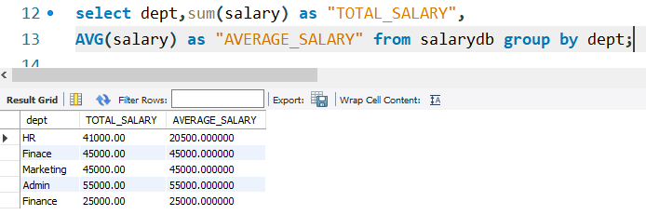

**Step 6: Find the number of employee working for each department**

**SQL>** **select dept,count(*) as "NUMBER_OF_EMPLOYEES" from salarydb group by dept;**

**Execution: -**

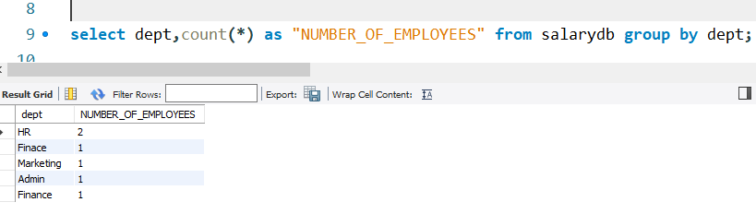

**Step 7: Display employee information in ascending and descending order of their date of joining.**

**SQL>** **select * from salarydb order by DOJ ASC;**

**Note : - (** smallest value to largest value) *****Check*****

**SQL>select * from salarydb order by DOJ DESC;**

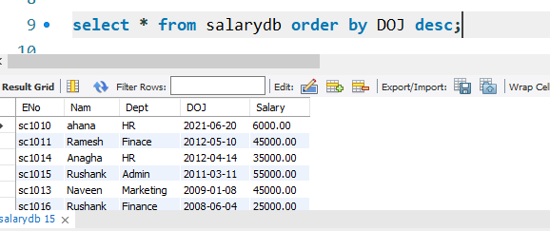

**Step 8: Find the highest salary that an Employee draws**

**SQL>** **select max(salary) as "HIGHEST_SALARY" from salarydb;**

**Execution: -**

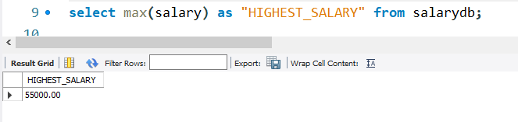

**Step 9: Find the least salary that an employee draws**

**SQL>** **select min(salary) as "LEAST_SALARY" from salarydb;**

**Execution: -**

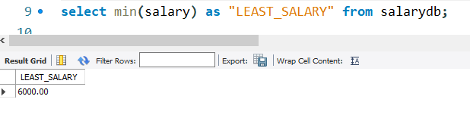

**Step 10: Display the details of employee whose name is Rushank and salary is greater than 55000.**

**SQL>** **select * from salarydb**

**where nam='rushank'and salary>50000;**